First create simple html page

As index.html

Write some message using tags.

index.html

<!DOCTYPE html>

<html lang="en">

<head>

    <meta charset="UTF-8">

    <meta name="viewport" content="width=device-width, initial-scale=1.0">

    <title>Document</title>

</head>

<body>

    <h2>Welcome to simple web page deploy using docker with jenkin in ec2 instnace</h2>

</body>

</html>

Now we will create the Dockerfile

FROM nginx

COPY index.html /usr/share/nginx/html

Now make this folder as local repository

git init

git add .

git commit -m “initial project ready”

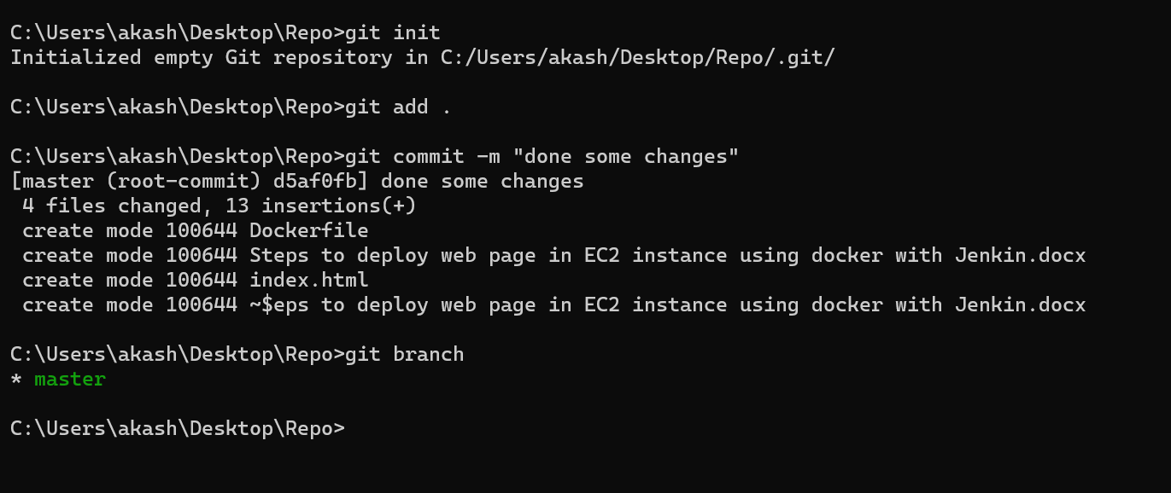

Now please create remote repository.

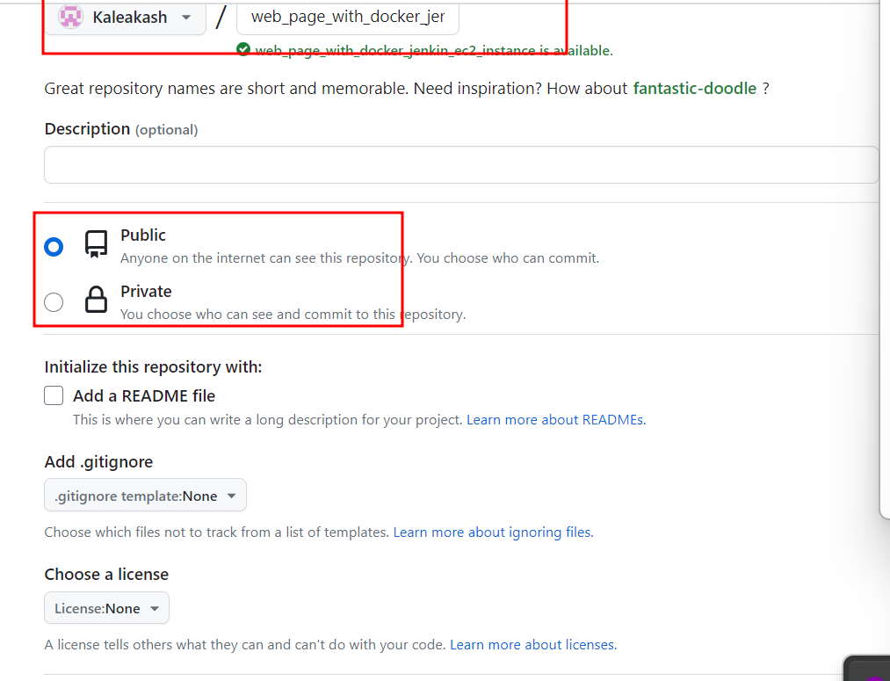

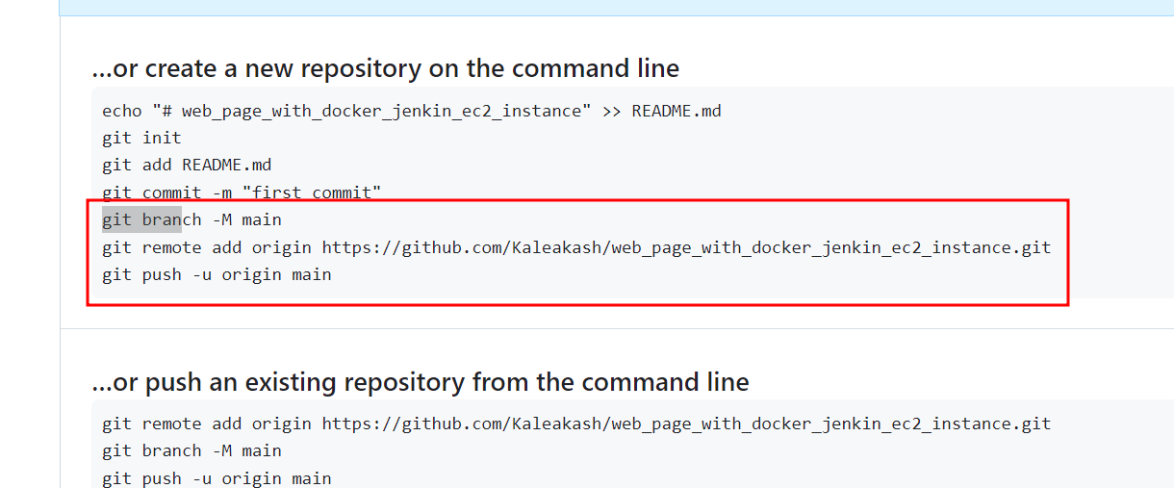

after push please check this code in your remote repository.

Please login to AWS account.

Then search EC2 instance option

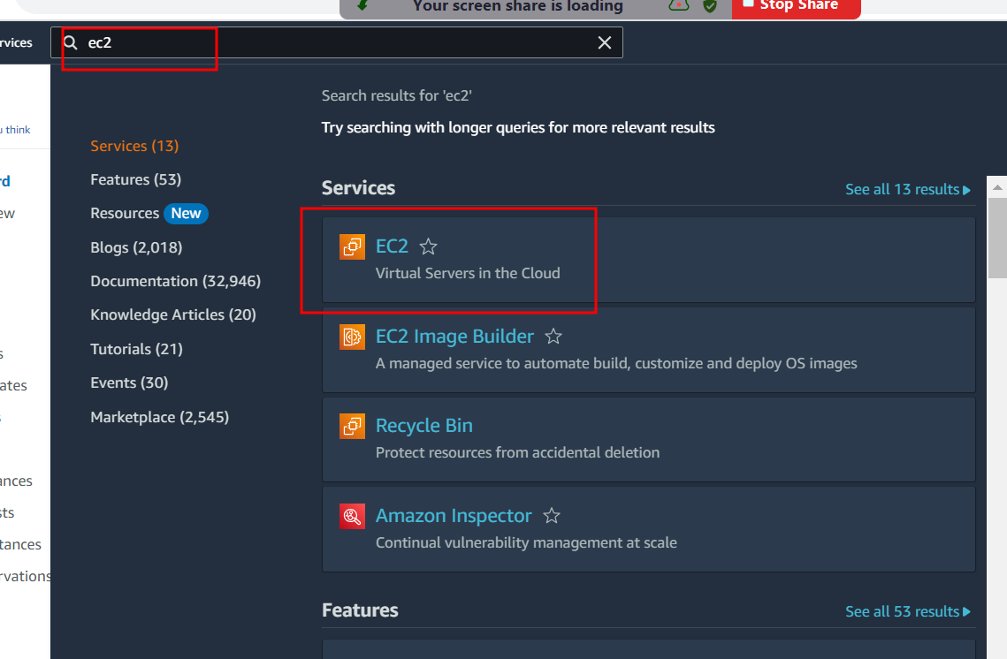

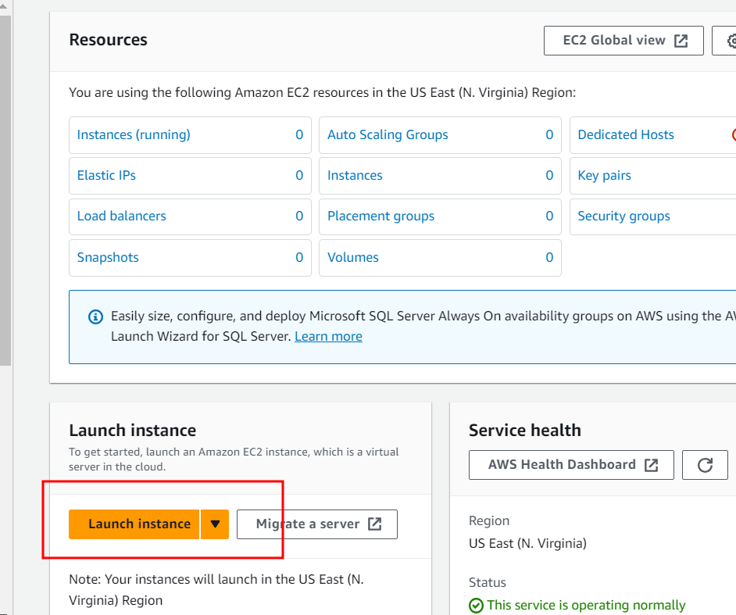

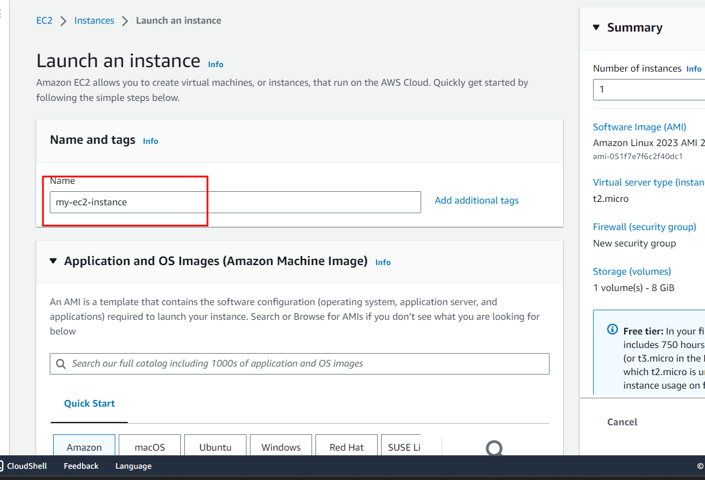

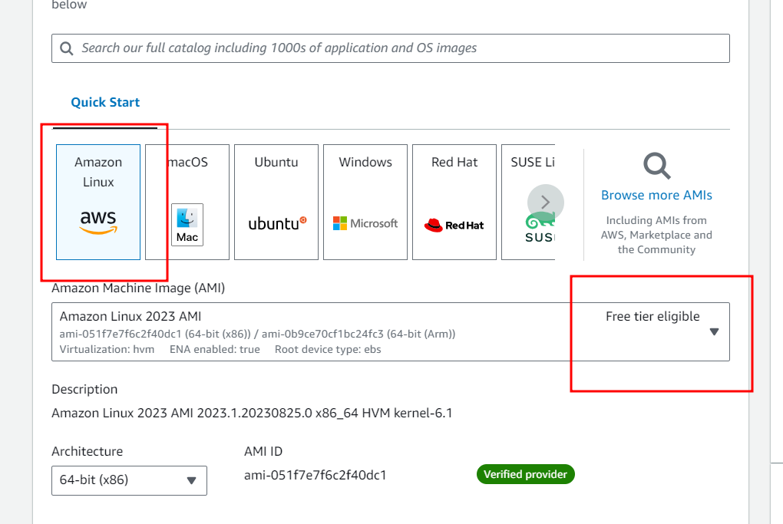

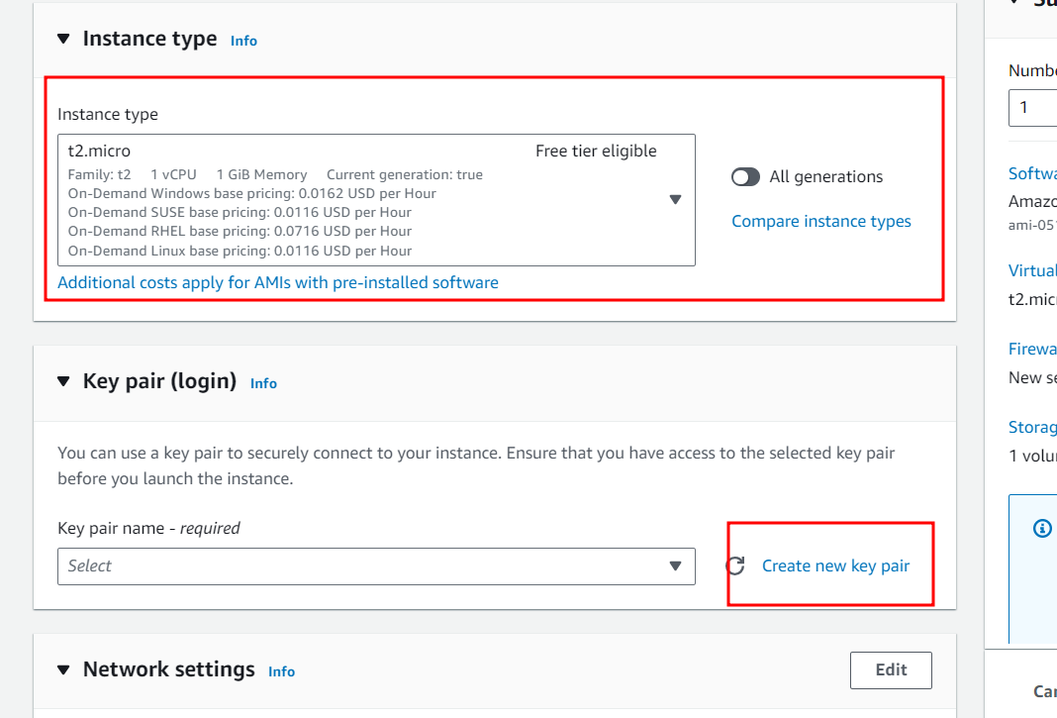

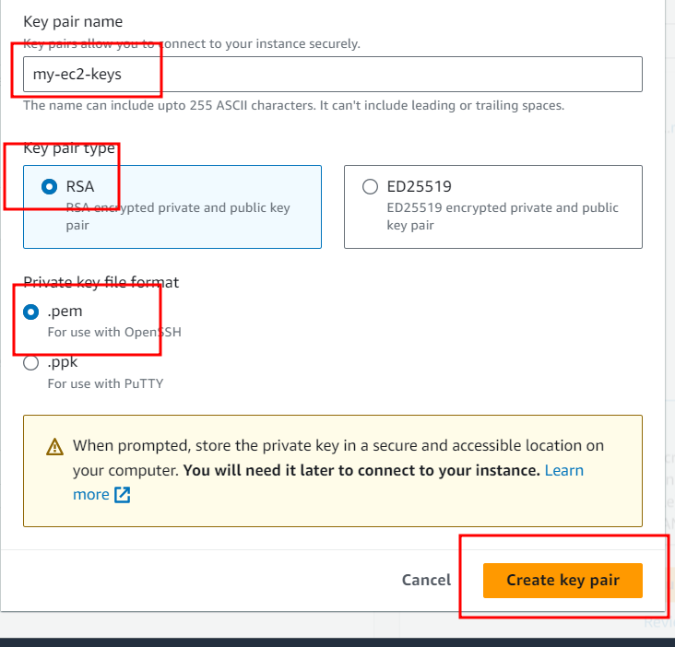

Download key and remember key path.

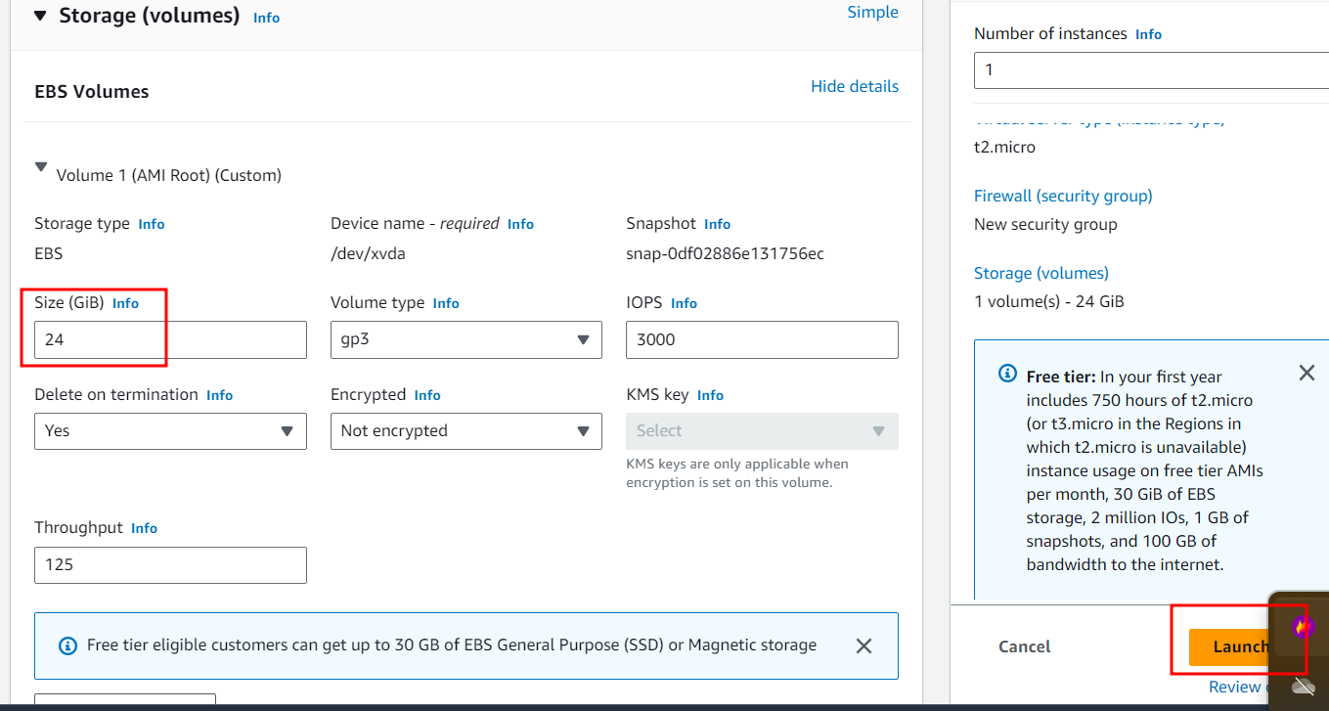

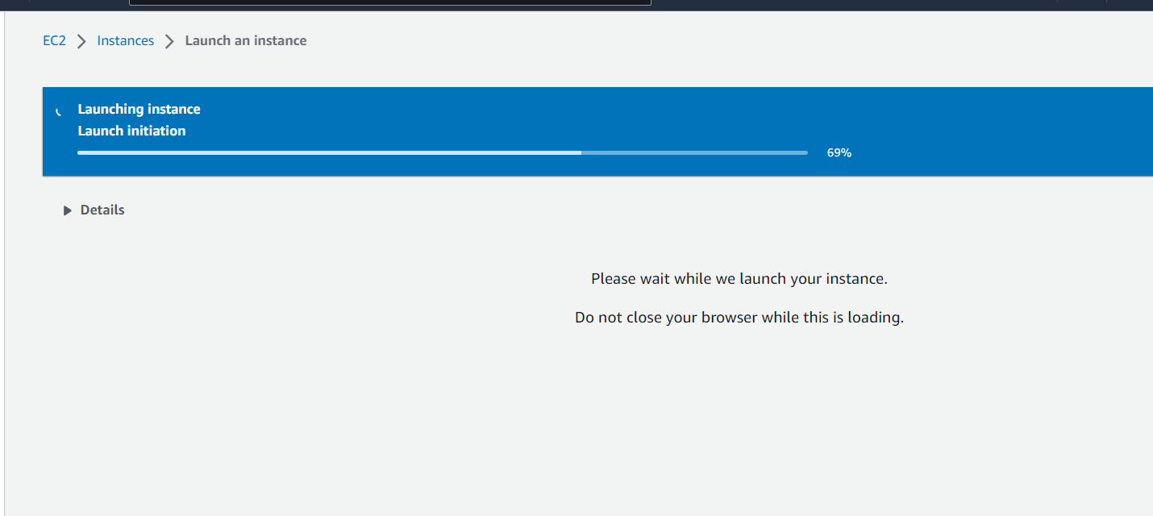

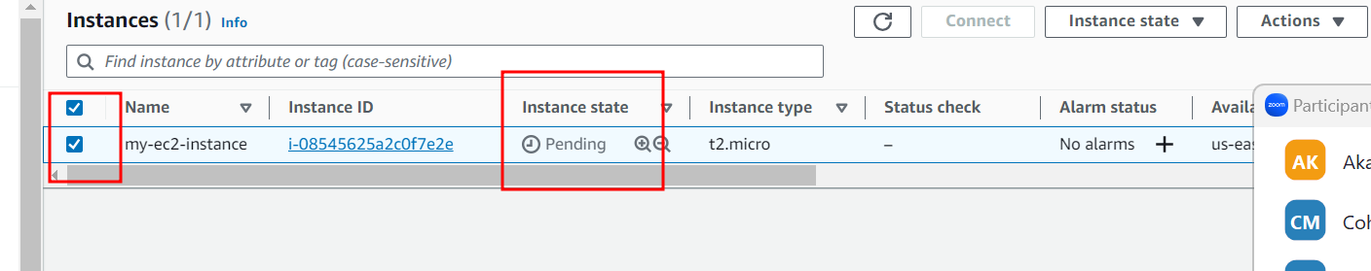

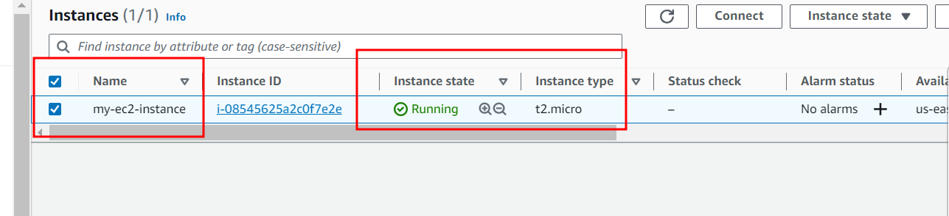

Now in EC2 instance we will open all port

80🡪 html page with nginx server

8080🡪 Jenkin

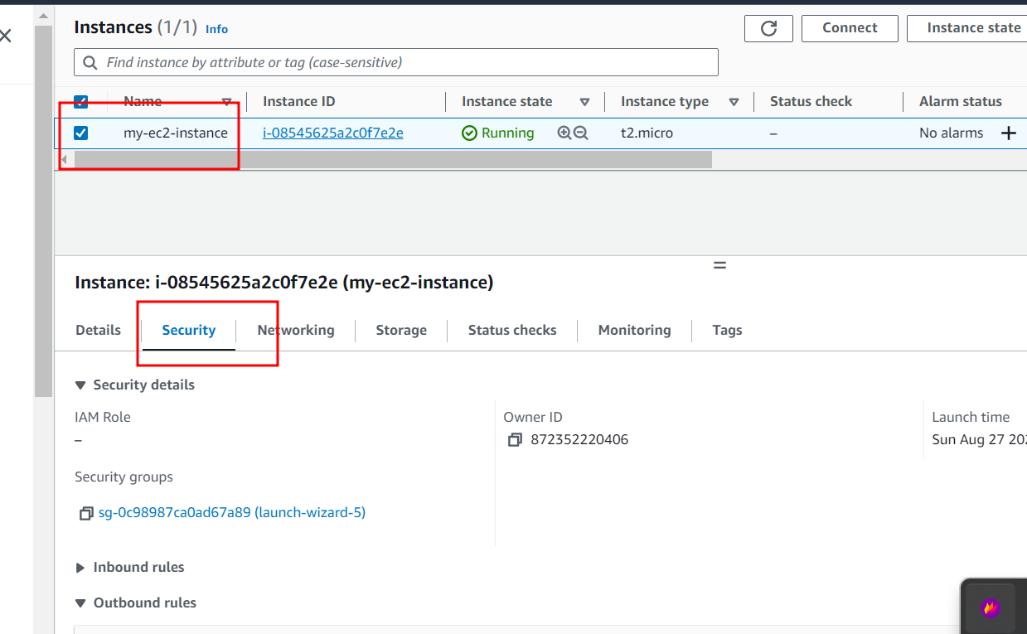

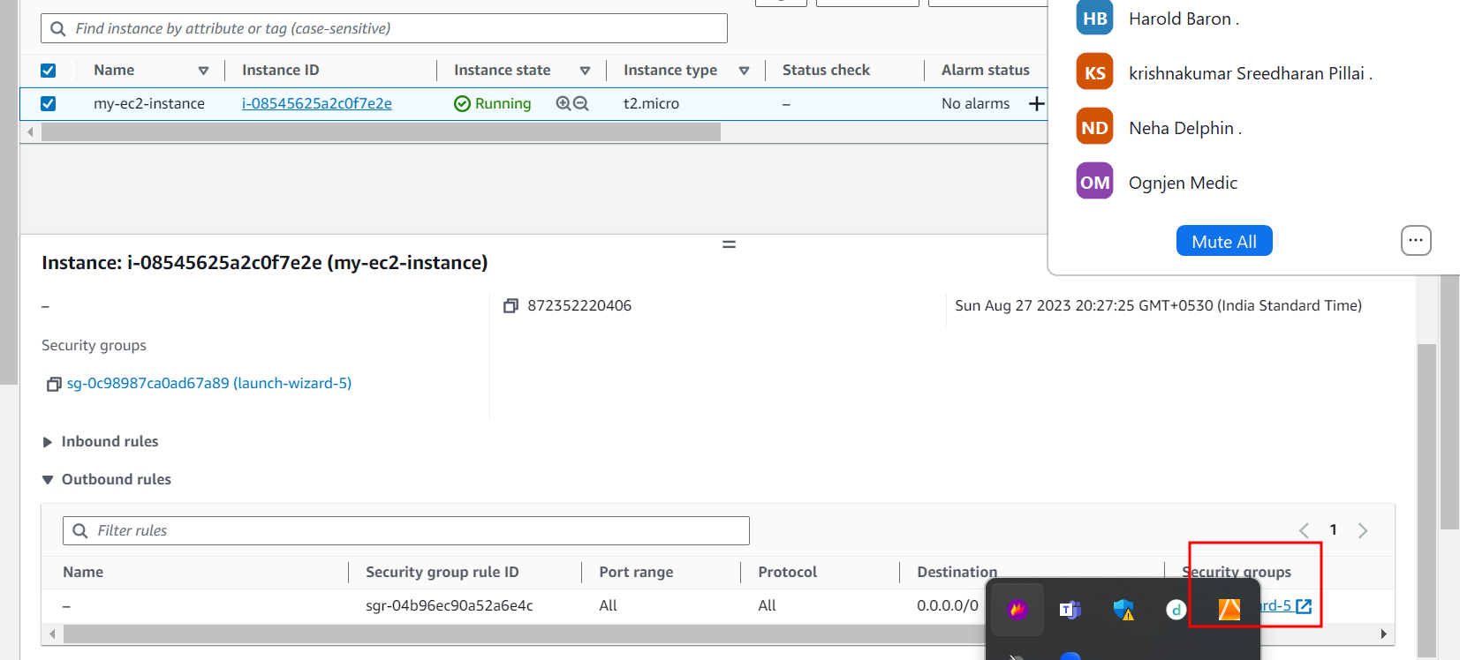

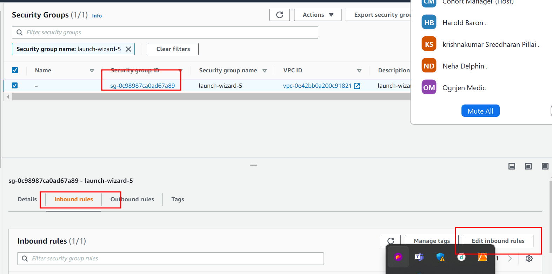

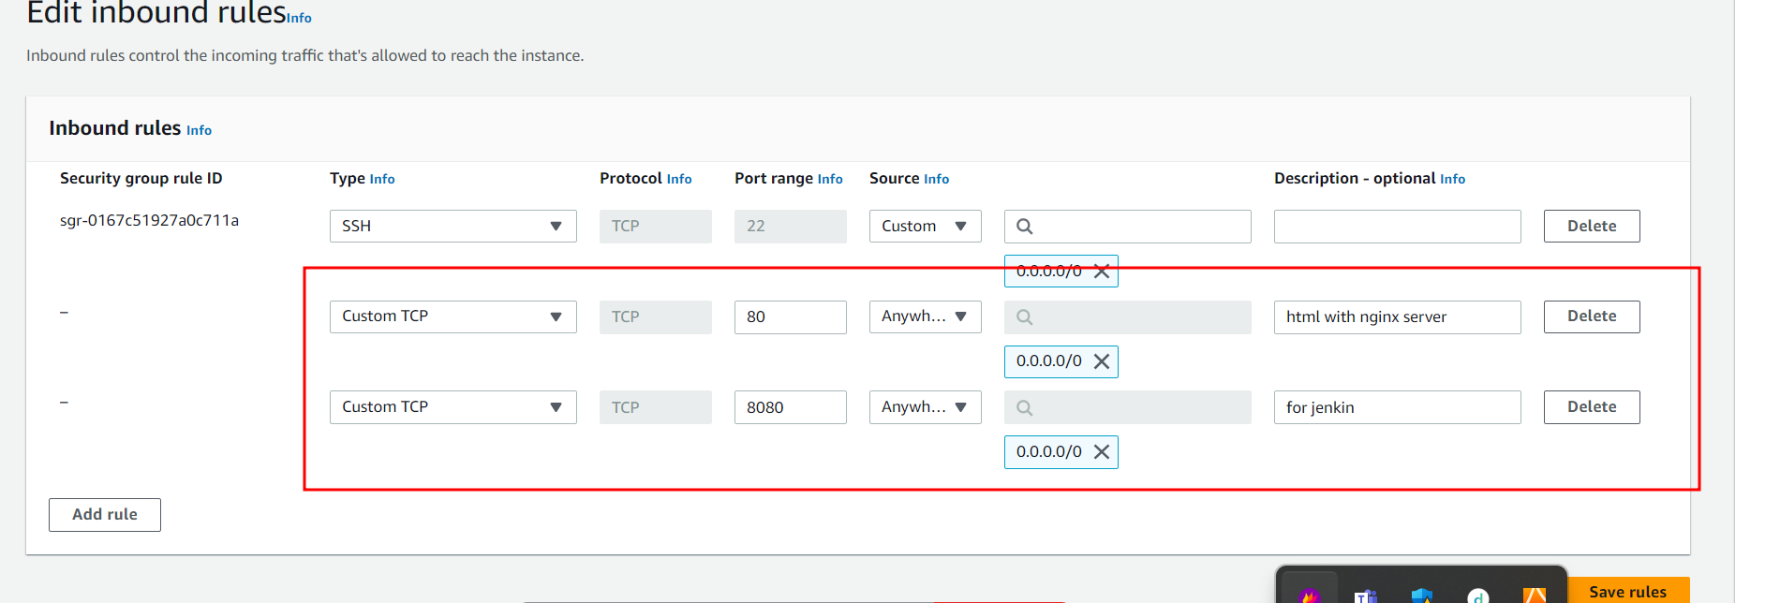

Close security wizard tab.

Now we are going to connect EC2 instance using terminal

Ie git bash (for window user)

Non window user (normal terminal)

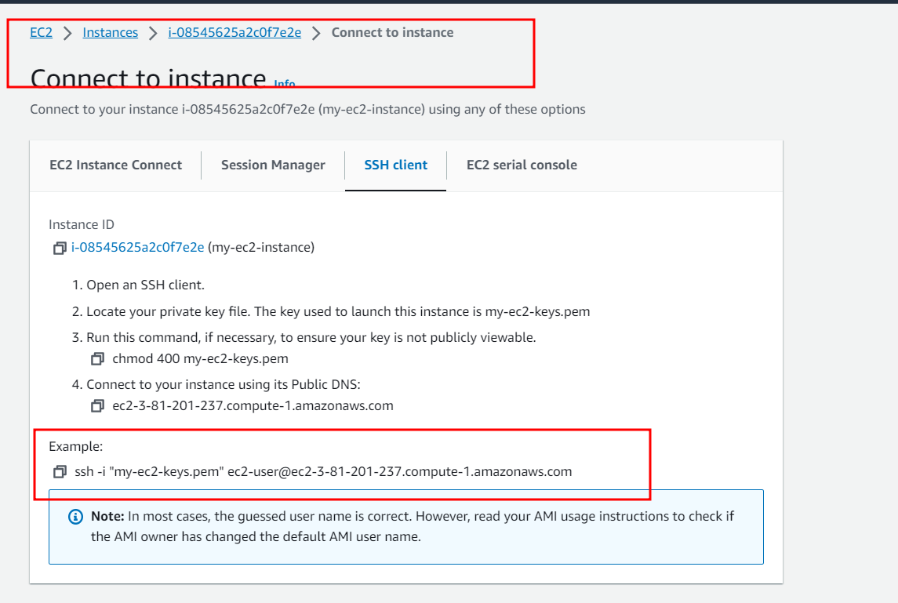

Please copy example ssh client commands

Then open git bash or normal terminal (but make sure .pem key file present int that location).

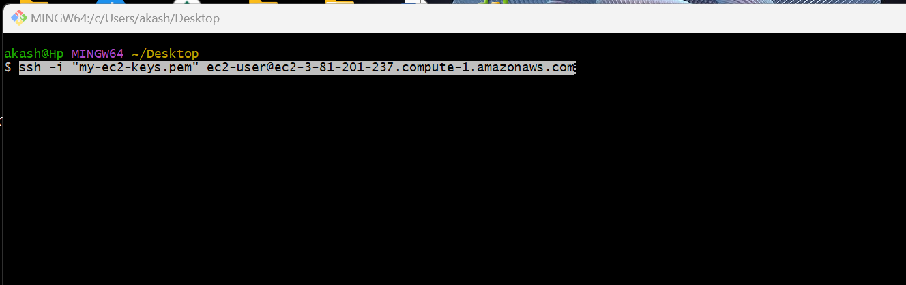

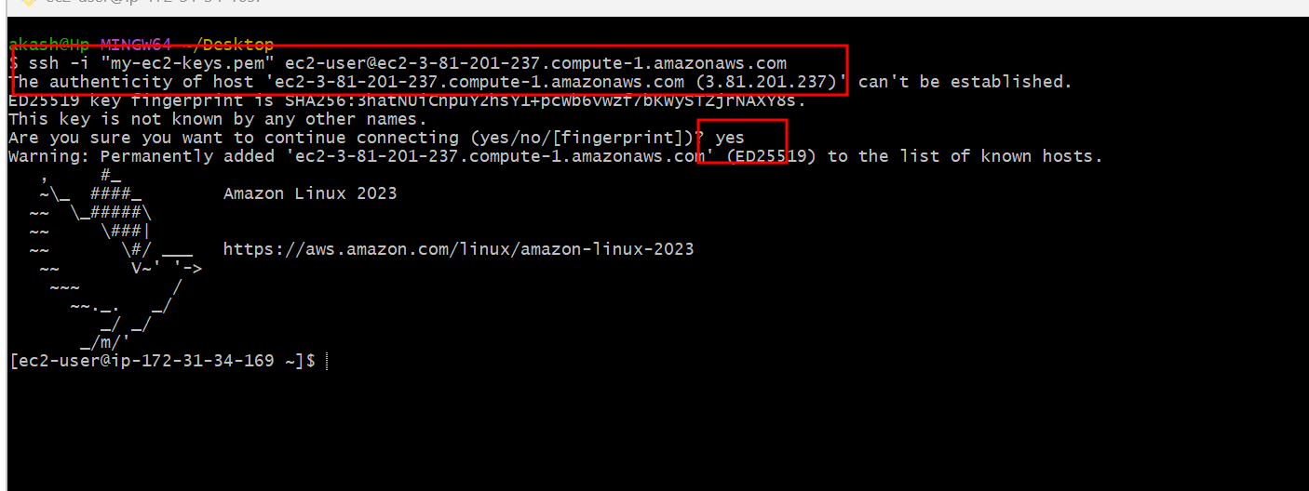

Now we need to install all required software in EC2 instance.

Git install

sudo yum install git -y

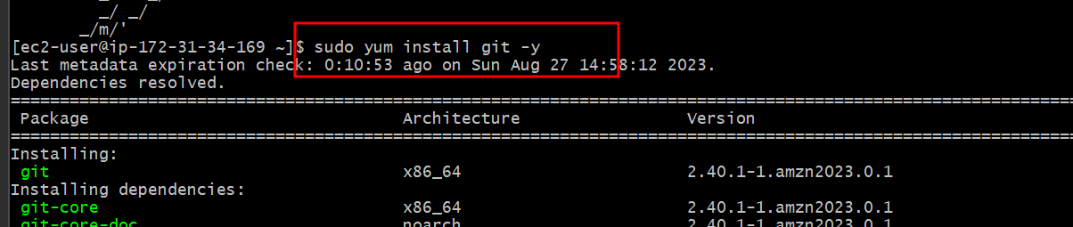

Java install

sudo yum install java-11

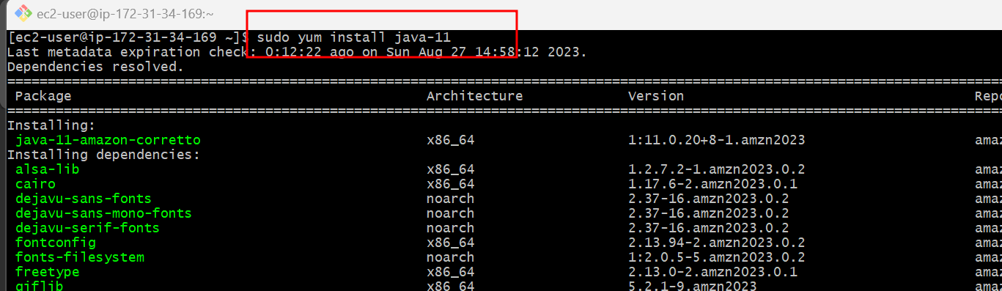

**Jenkin install**

sudo wget -O /etc/yum.repos.d/jenkins.repo <https://pkg.jenkins.io/redhat/jenkins.repo>

sudo rpm --import <https://pkg.jenkins.io/redhat-stable/jenkins.io.key>

sudo yum install jenkins

after installation we need to start the Jenkin

sudo service jenkins start this command to start

sudo systemctl status jenkins this is use to check the status

to exit that flow please type cntr + c twice

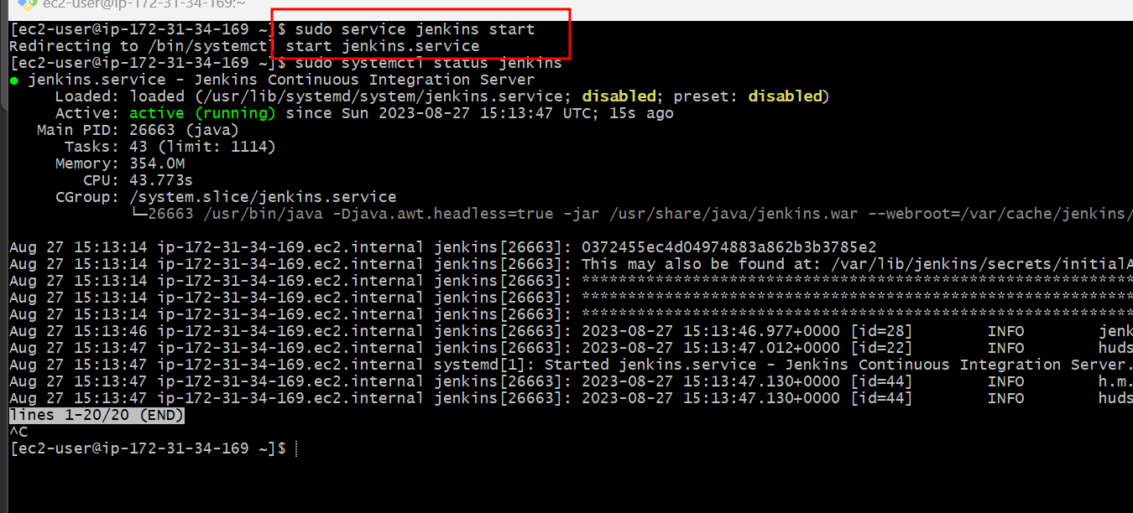

Docker install

sudo yum install docker

sudo service docker start

sudo docker --version

Provide permission to run docker and docker compose command in Jenkin environment.

sudo usermod -a -G docker jenkins

sudo usermod -a -G docker ec2-user (ec2-user is user name of instance )

sudo chmod 777 /var/run/docker.sock

after this please restart Jenkins or ec2 instance.

Please sudo reboot command restart ec2 instance to update all changes.

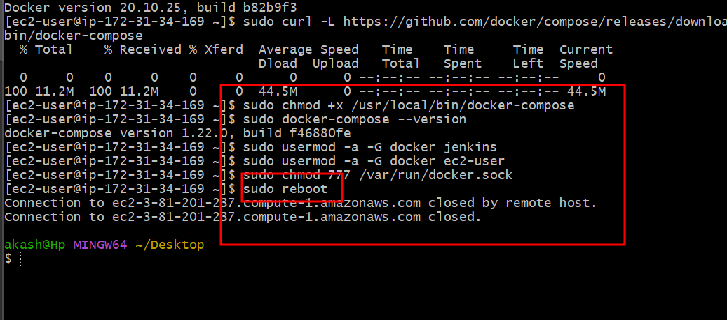

Wait for few minutes to start ec2 instance.

After reboot please connect to ec2 instance using ssh client command

Then start Jenkin service once again using command as

sudo service jenkins start

after start Jenkin please open ec2 dashboard then check Ec2 instance IP Address

hit on browser as <http://ipaddress:8080>

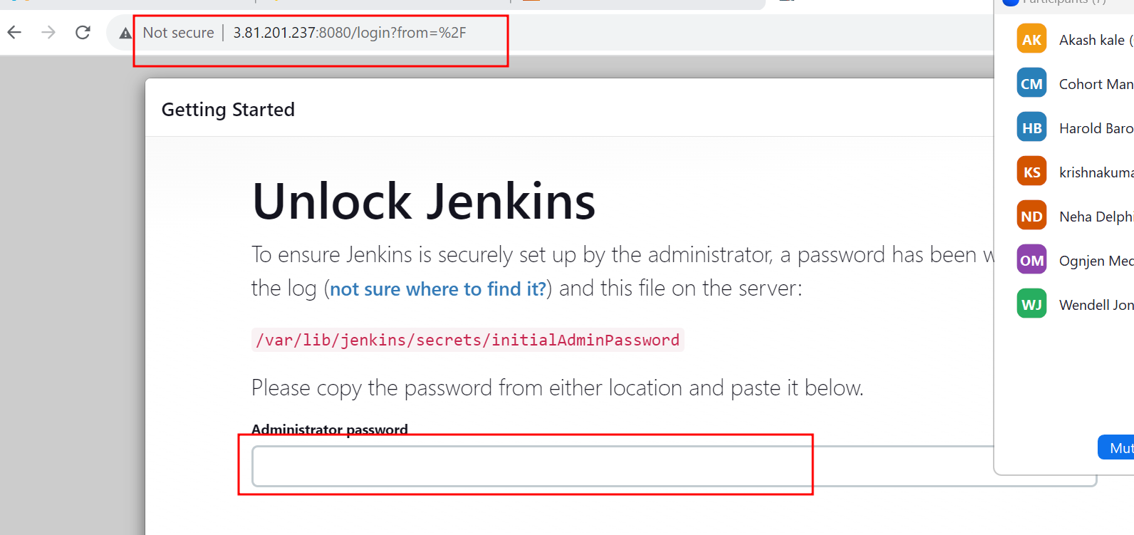

At the first time it will ask random password.

To get the password please write the command in ec2 instance as

sudo cat /var/lib/jenkins/secrets/initialAdminPassword

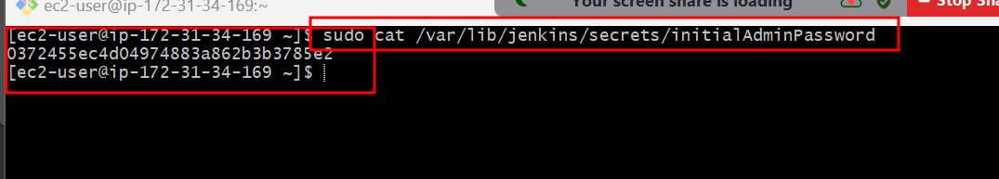

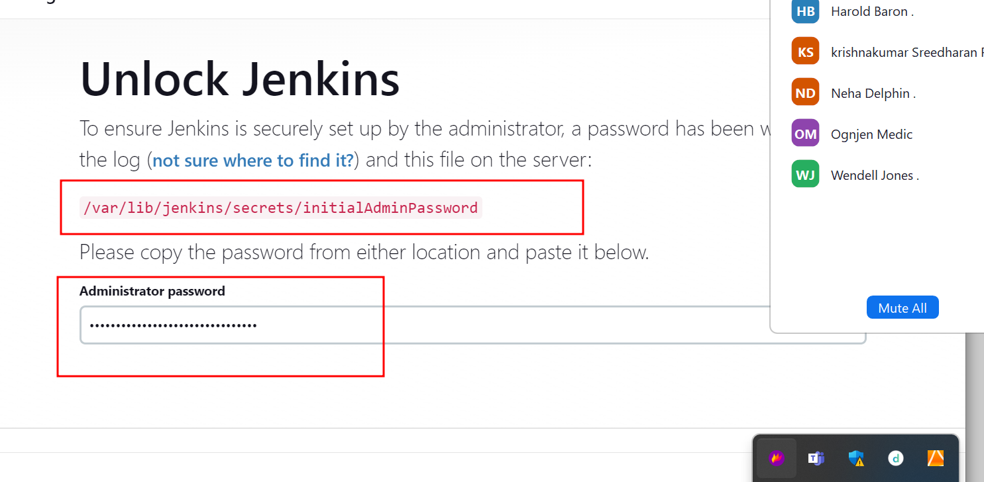

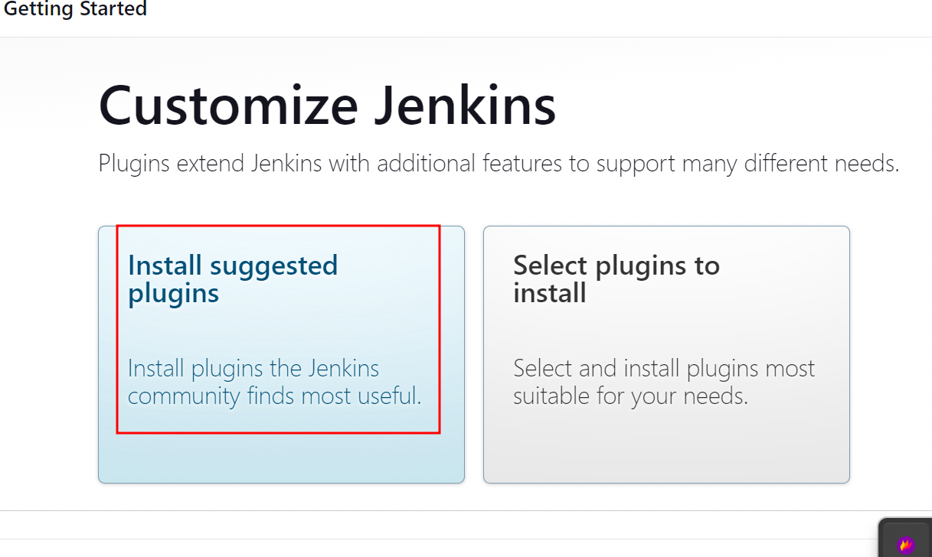

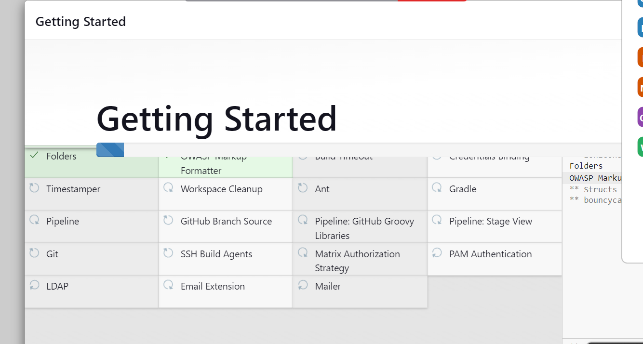

Then create your own account.

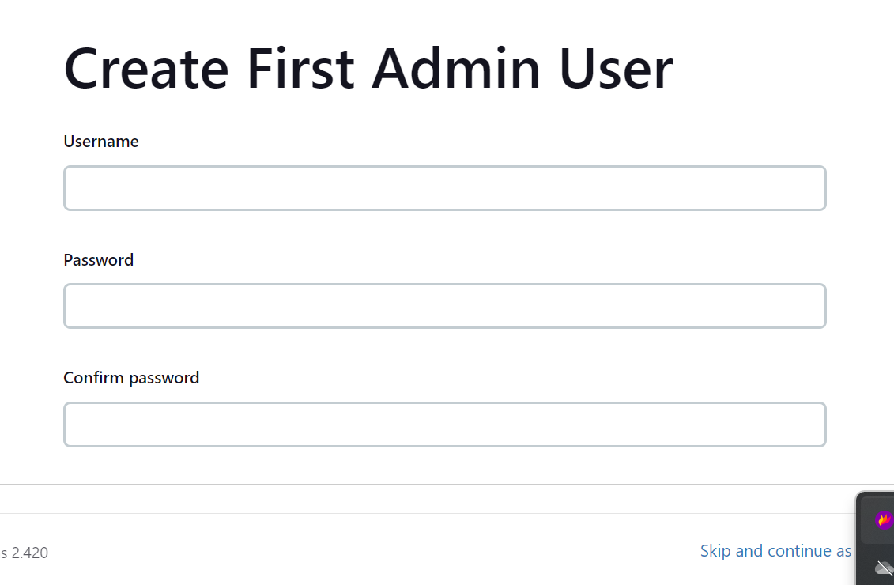

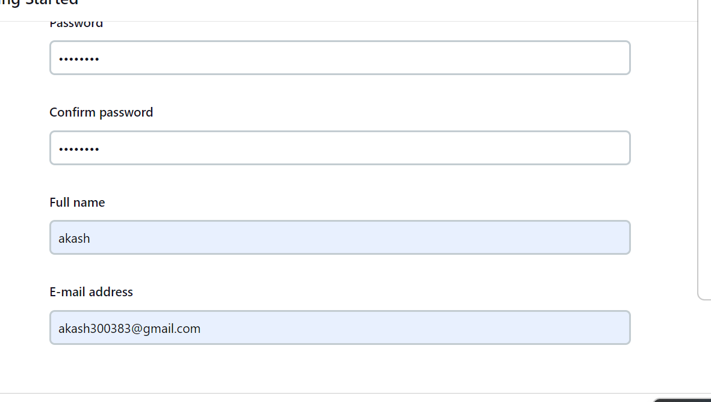

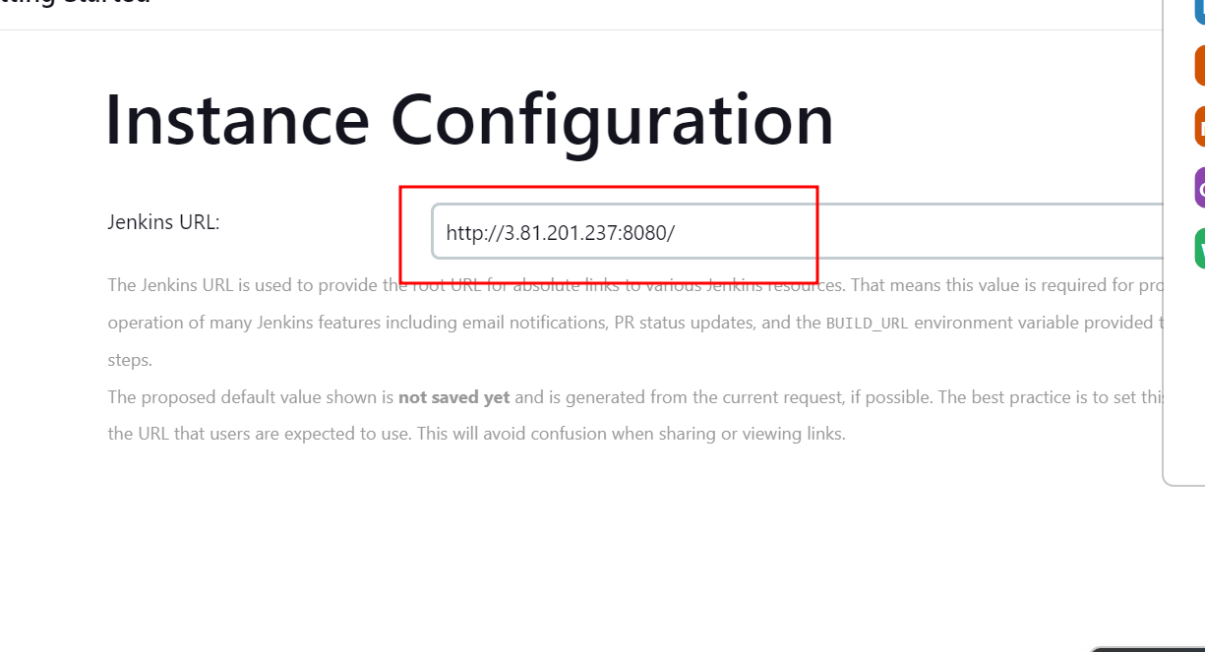

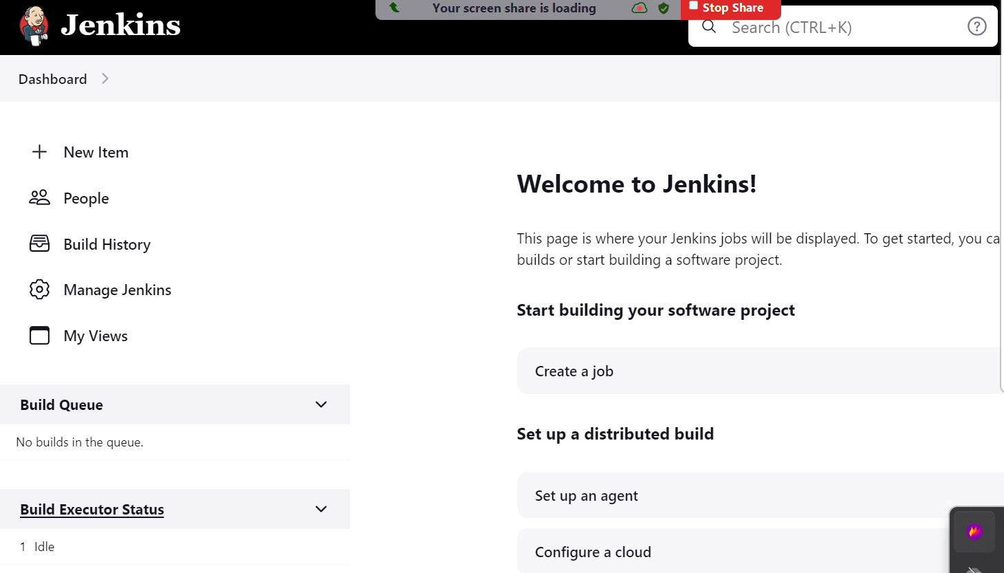

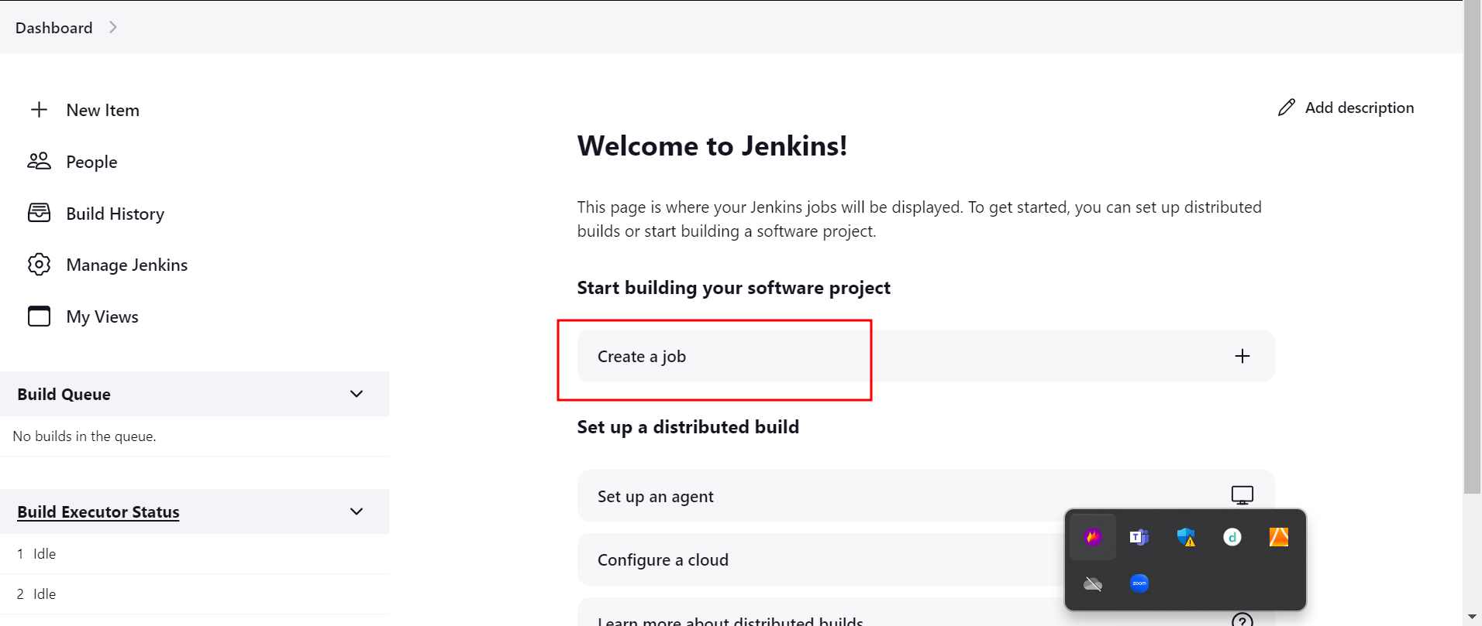

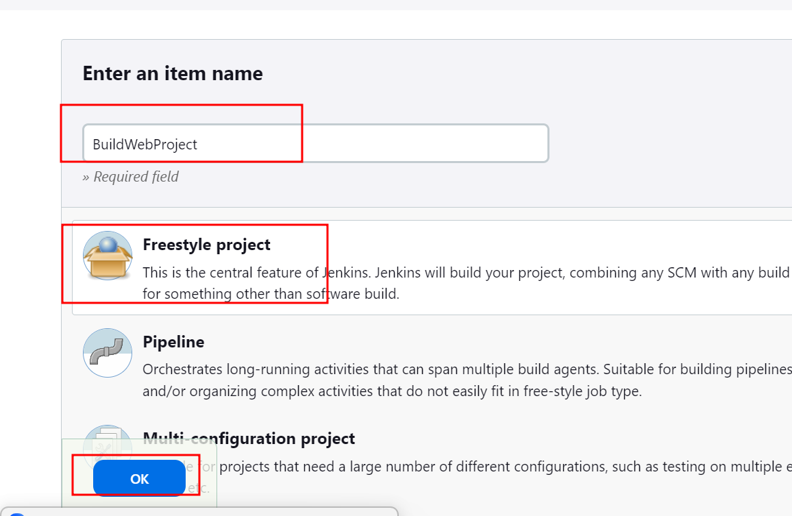

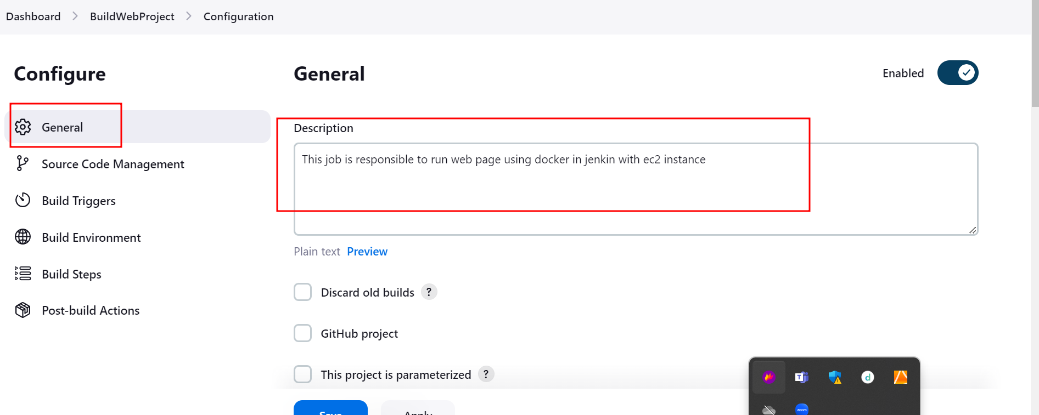

Git url is

<https://github.com/Kaleakash/web_page_with_docker_jenkin_ec2_instance.git>

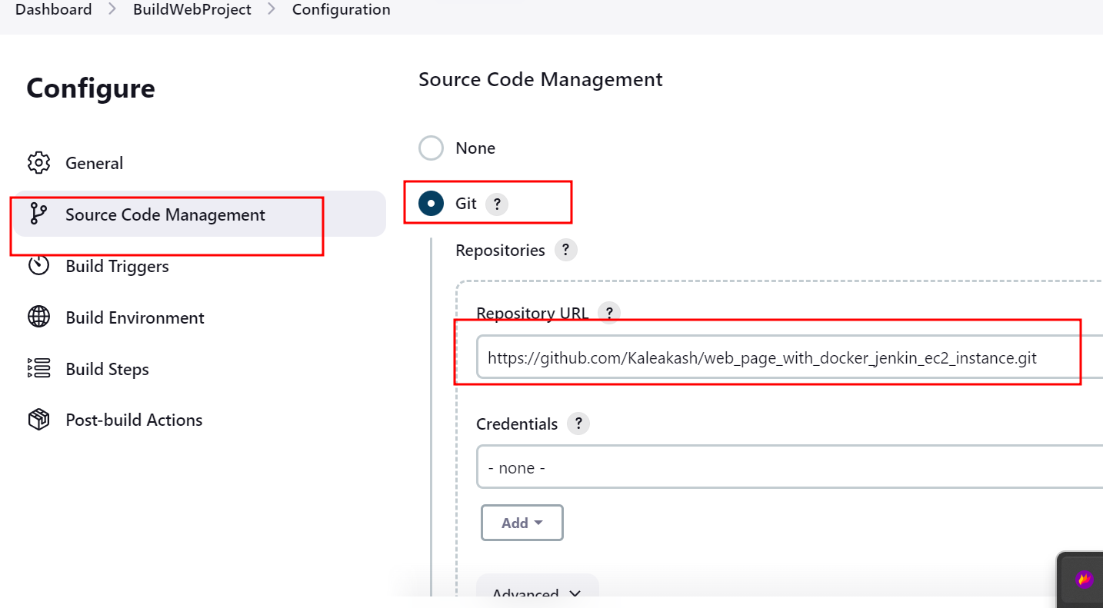



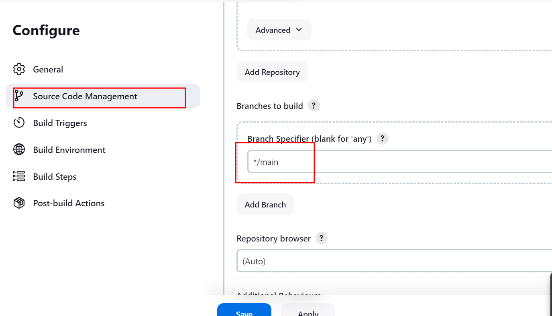

Please make sure branch must be same.

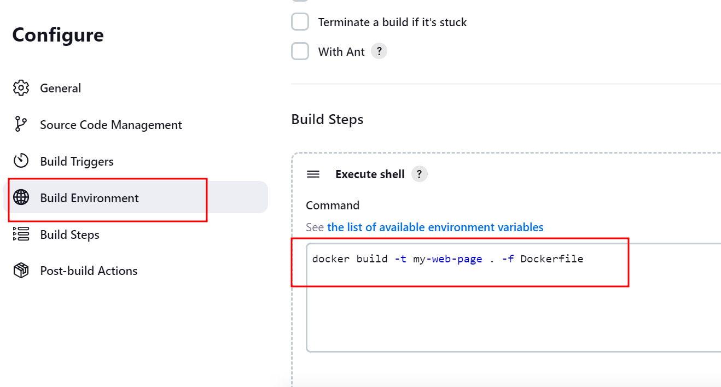

This command is use to build the image

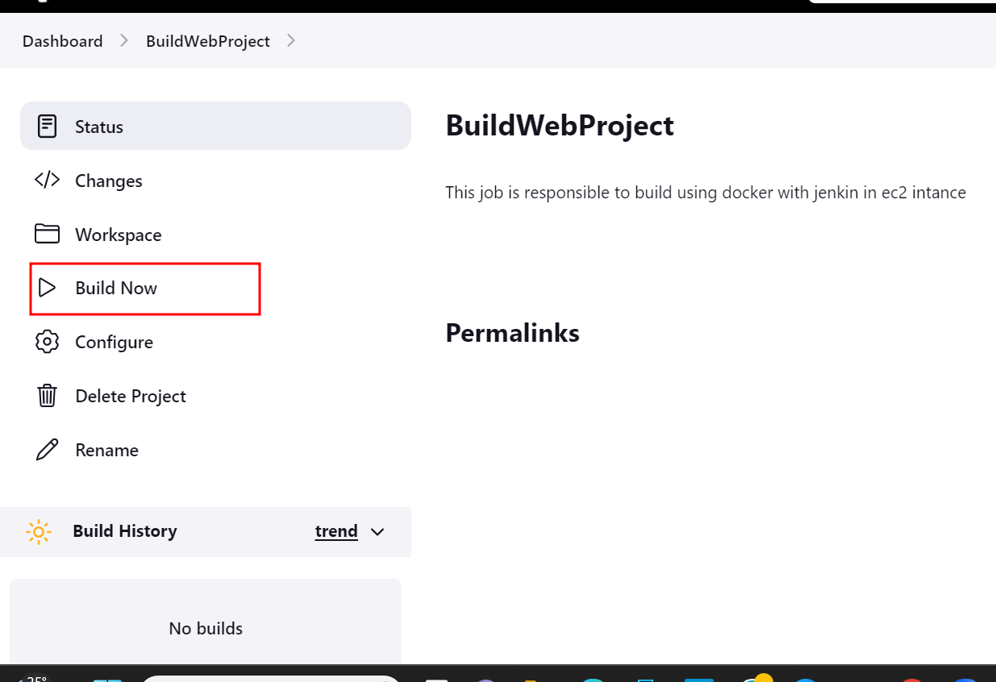

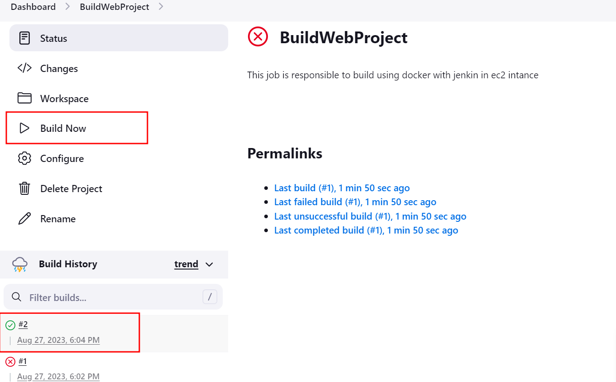

After successfully images creation please check the console.

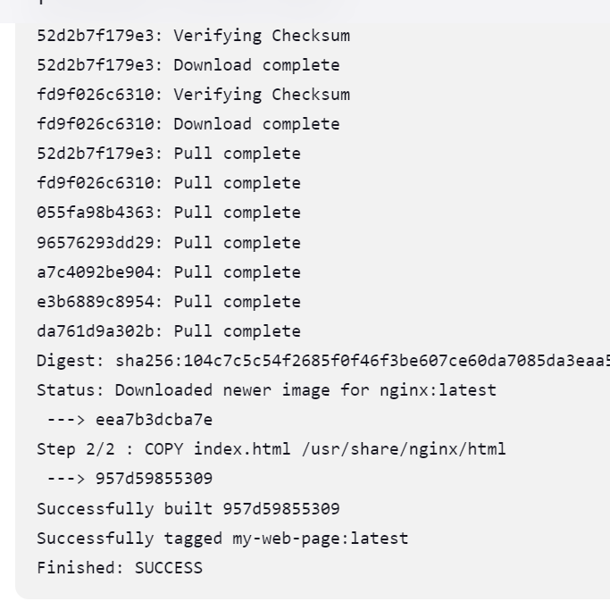

If you want to run the image then run the command as

docker run -d -p 80:80 my-web-page

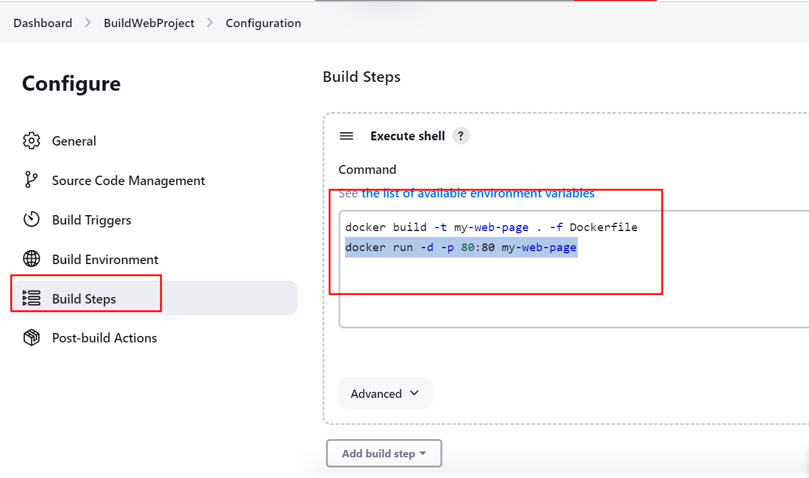

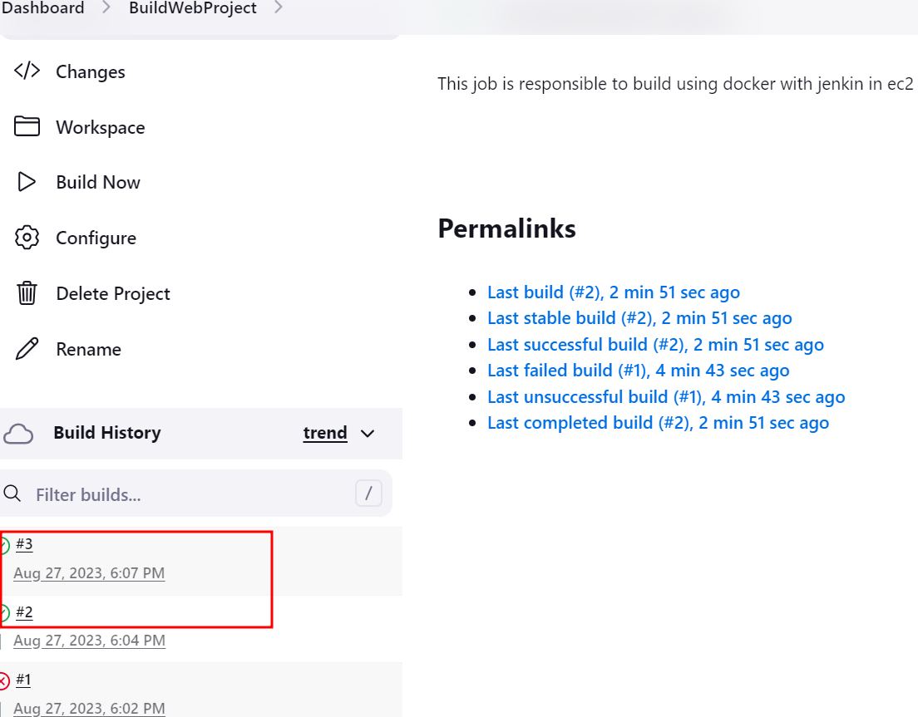

Then using ip address you can view that simple html page

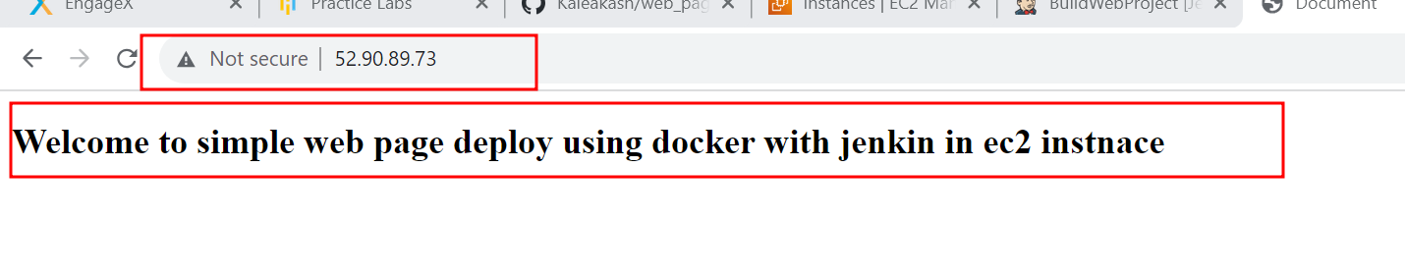

Now we will use trigger option in Jenkin project.

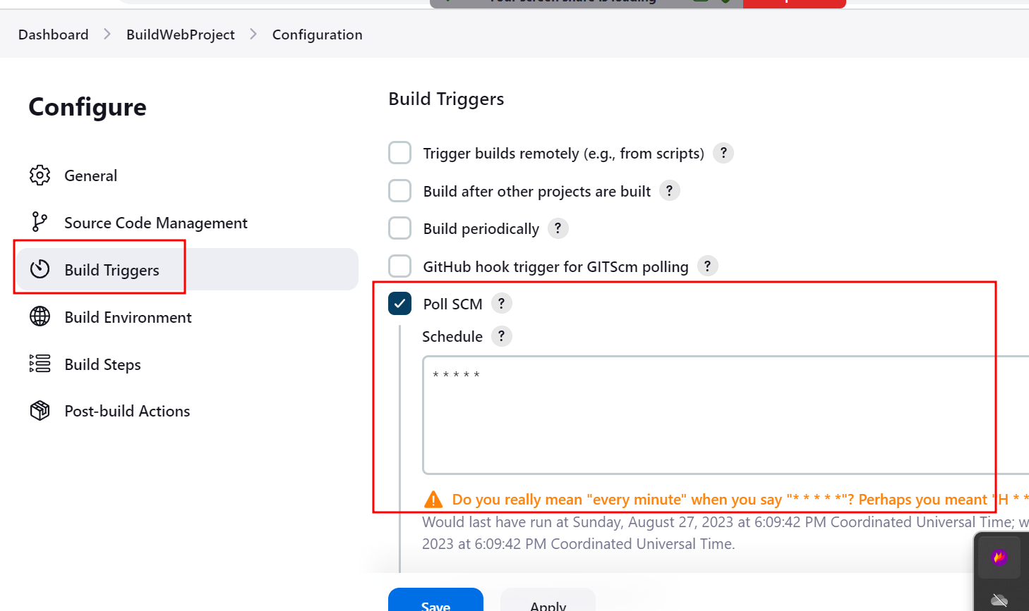

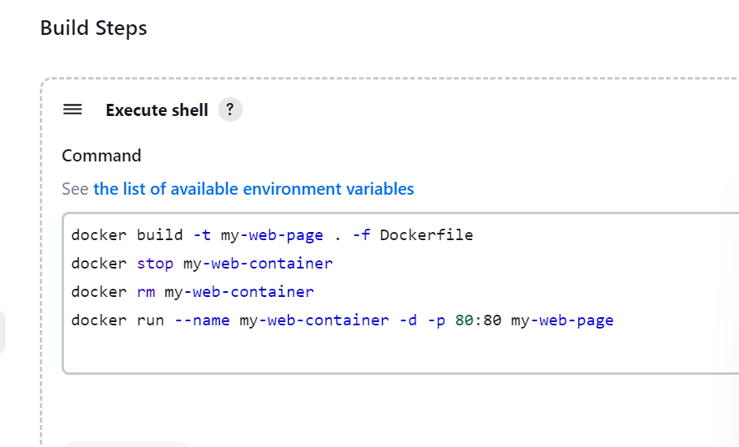

So do the changes in local machine in index.html page

Then add it

Commit it

And push it

So Jenkin automatically build this project after 1 minutes

Can you can see new updated without manually build.